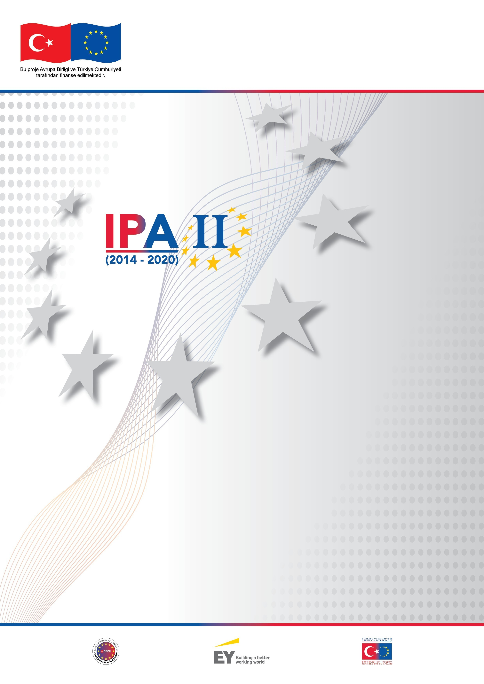
Ministry for EU Affairs
Technical Assistance for IPA II
(2014-2020)
Advanced Training on IPA II Monitoring, Reporting and Evaluation Framework

Training Agenda

Training agenda
Advanced Training on IPA II Monitoring, Reporting and Evaluation Framework
16-20 January 2017 Ankara
Swiss Hotel, İstanbul Room
Trainers: Galina Karamotcheva and Tatjana Arsova
Training Agenda
Day 1 – 16.01.2017
Sessions | Topic | Methodology
10:00-10:40 | Welcome  Introduction to the training  Training programme overview  Entry test | Presentation
10:40-11:15 | Monitoring and evaluation under IPA II – Legal provisions, role and responsibilities | Presentation  Questions & Answers
11:15-11:30 | Break
11:30-12:30 | Results-based management – phases, benefits and opportunities and constrains for development | Quiz on monitoring and evaluation functions and roles  Presentation  Questions & Answers
12:30-13:30 | Lunch break
13:30-14:45 | Results chain and results / performance frameworks  Learning on review of good quality performance frameworks | Presentation  Questions and answers  Individual exercise – outcome levels  Review of cases
14:45-15:00 | Coffee Break
15:00-16:30 | Results-based monitoring and evaluation | Presentation  Questions & Answers

Day 2 – 17.01.2017
Sessions | Topic | Methodology
10:00-11:15 | IPA II performance framework. Operational performance indicators – approaches for linking sector with action indicators | Presentation  Questions and answers  Exercise – selection of operational performance indicators  Review and discussion of case study on indicators systems
11:15-11:30 | Coffee Break
11:30-12:30 | Review of technical quality of performance indicators  Baselines and targets | Presentation  Questions and answers  Exercise for review of technical quality of indicators
12:30-13:30 | Lunch
13:30-14:45 | Collection of data on performance indicators – roles, methods, responsibilities | Presentation  Exercise on preparation of indicator fiches
14:45-15:00 | Coffee Break
15:00-16:30 | Data analysis and reporting on indicators | Presentation  Exercise on planning of data analysis  Questions and answers

Day3 18.01.2017
Sessions | Topic | Methodology
10:00-11:15 | Planning of monitoring activities on contract /activity level - monitoring cycle, phase of implementation and methods, OS monitoring and ROM reviews | Presentation  Questions and answers
11:15-11:30 | Coffee Break
11:30-12:30 | Action/contract level risk management and risk mitigation measures | Presentation  Questions and answers  Exercise on identification of project risks
12:30-13:30 | Lunch
13:30-14:45 | Planning and conducting monitoring visits | Presentation  Questions and answers  Simulation exercise - conducting monitoring visit
14:45-15:00 | Coffee Break
15:00-16:30 | Preparation of monitoring and progress reports | Presentation  Questions and answers  Discussion

Day 4 19.01.2017
Sessions | Topic | Methodology
10:00-11:15 | Evaluation of IPA II assistance - evaluation requirements and standards | Presentation  Questions & Answers  Case study evaluation standards
11:15-11:30 | Coffee Break
11:30-12:30 | Evaluation management. Types of evaluation. Phases of evaluation. Evaluation plan and evaluation roadmap | Presentation  Questions & Answers  Exercise evaluation plan
12:30-13:30 | Lunch
13:30-14:45 | Evaluation purpose and evaluation questions | Presentation  Individual exercise –evaluation questions
14:45-15:00 | Coffee Break
15:00-16:30 | Assessment of data requirements for evaluations | Presentation  Questions & Answers

Day 5 20.01.2017
Sessions | Topic | Methodology
10:00-11:15 | Planning of evaluation resources.  Preparation of evaluation road map and ToR for evaluation | Presentation  Exercise for estimation of resources and time frame for evaluation
11:15-11:30 | Coffee Break
11:30-12:30 | Group exercise quality of ToR for evaluation | Case study – improvement of ToR
12:30-13:30 | Lunch
13:30-14:45 | Management of evaluation. Assessment of quality of the evaluation reports | Presentation  Case study
14:45-15:00 | Coffee Break
15:00-16:00 | Dissemination of the evaluation and follow-up process | Presentation  Discussion
16:00 -16:30 | Exit tests  Evaluation of the training by participants

